Define Problem Statement

Date | 2 November 2025
Team ID | NM2025TMID00585
Project Name | Laptop Request Catalogue Items
Maximum Marks | 4

Problem Statement Overview
In most organizations, the process of requesting laptops or other IT assets is slow, inconsistent, and dependent on manual communication. Employees who need laptops for work—whether for onboarding, project requirements, or hardware replacement—often face unclear procedures and delayed responses. The absence of a proper digital system results in inefficiency and confusion among all parties involved.
Currently, laptop requests are made through email threads or paper-based forms, which are prone to miscommunication and data loss. Employees may not know the correct person or department to approach, leading to multiple follow-ups and redundant submissions. This unstructured approach also causes delays in approval since managers must manually verify each request, its justification, and device availability.
The IT department, on the other hand, faces challenges in tracking laptop stock, issuing devices, and maintaining proper records. Without an automated catalogue or request log, it becomes difficult to monitor which employee has which device, when it was issued, and when it is due for return or replacement. This lack of transparency can lead to inventory mismatches, unplanned purchases, and higher operational costs. Additionally, there is no standardized way to compare or choose laptop configurations suited to specific job roles. Employees may not be aware of available models, specifications, or pricing differences. Managers, too, spend extra time validating whether a requested device aligns with the organization’s IT policies and budget.
Therefore, there is a strong need for a centralized, digital Laptop Request Catalogue System that simplifies the entire process — from submission to approval to allocation. The system should allow employees to view available laptops, select suitable options, submit requests with proper justification, and track approval status in real-time. It should also help managers make informed decisions based on accurate data and enable IT teams to maintain a clear, automated record of asset distribution.
Implementing such a system will not only reduce manual effort and approval delays but also bring consistency, transparency, and accountability into laptop management across the organization. Ultimately, this contributes to smoother onboarding, better resource utilization, and a more efficient IT workflow.

Problem | Current laptop request process is manual and inefficient.
Impact | Delays in approval and lack of visibility in request status.
Goal | Provide an online catalogue and transparent laptop requests.
Expected Outcome | Faster approvals, improved tracking, and reduced workload.

Problem Description
The manual system lacks automation, leading to multiple follow-ups and unclear communication. Employees often don't know the status of their requests, and administrators face challenges managing inventory. Our solution introduces a structured, automated workflow for request creation, approval, and allocation. Moreover, IT teams struggle to manage inventory efficiently. Without a digital system, it becomes difficult to track issued laptops, maintain return logs, and plan future procurements. This lack of visibility can result in over-purchasing or resource shortages. A structured and automated system is essential to ensure transparency, accountability, and faster processing of laptop requests across all departments.
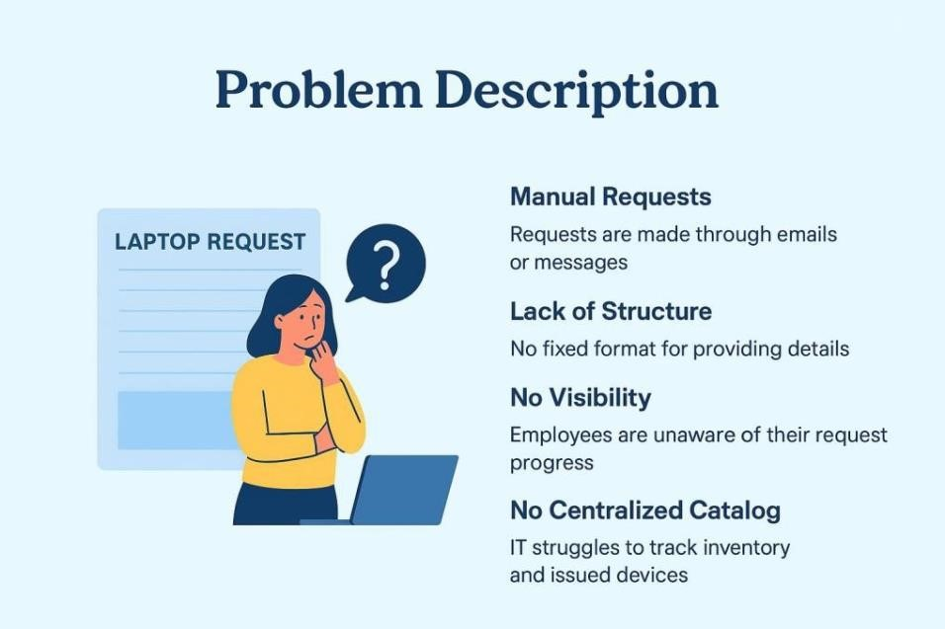

The absence of data tracking also prevents organizations from analyzing trends, such as the most requested models, average approval time, or budget spent on hardware. Such insights are valuable for procurement planning and cost optimization, but they are lost due to manual handling. Therefore, the lack of an automated, structured, and transparent system for laptop requests is a
serious bottleneck in organizational efficiency. A well-designed digital solution is needed to streamline this process, improve communication, and ensure accountability at every stage—from request submission to approval and device delivery.
Reference: https://miro.com/templates/customer-problem-statement/

Proposed Solution
The proposed Laptop Request Catalogue allows employees to select laptop models from a digital catalogue, submit requests online, and track status in real-time. Admins can approve or reject requests and manage stock levels. The system enhances transparency and reduces processing time significantly.
This project ensures a smoother laptop allocation process with reduced manual effort and better tracking. By digitalizing the request flow, organizations can improve operational efficiency, reduce approval times, and maintain resource records accurately.
The system also maintains a detailed log of issued devices, making it easy for IT administrators to monitor usage, plan replacements, and manage returns when employees leave the company.
Analytics and reporting features can provide insights into demand patterns, helping management make data-driven procurement decisions. By digitalizing the entire process, the organization can save time, reduce human error, and improve employee satisfaction.

